Practical No:08

**Aim:** Linux Editors: vim/gedit/nano

1. Create, modify, search, navigate a file in editor,

**Creating a file in vi editor:**

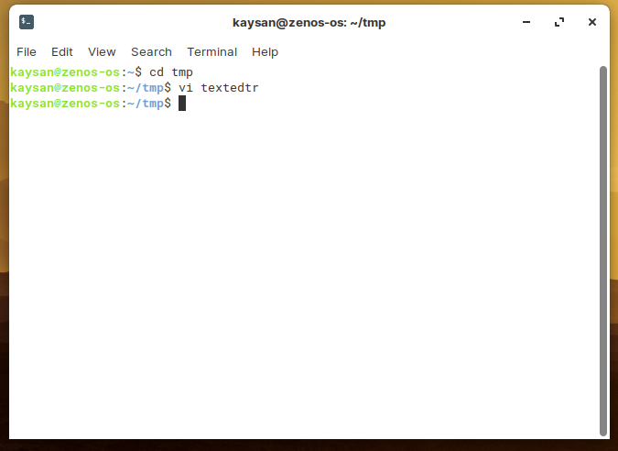

**Modification**

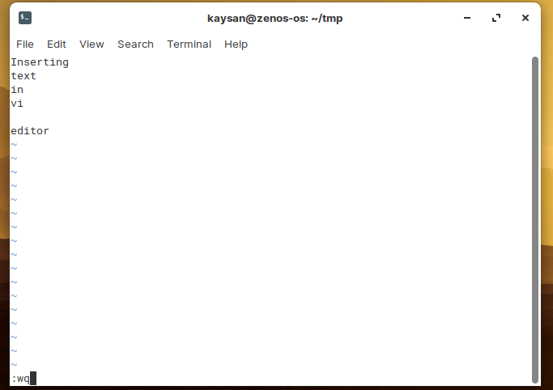

**~ represents an empty line**

**To insert text, press ‘i’ button**

**esc + :wq to save and exit**

**To Search**

**Press esc + ? followed by characters or words for backword search and esc + / for forward search.**

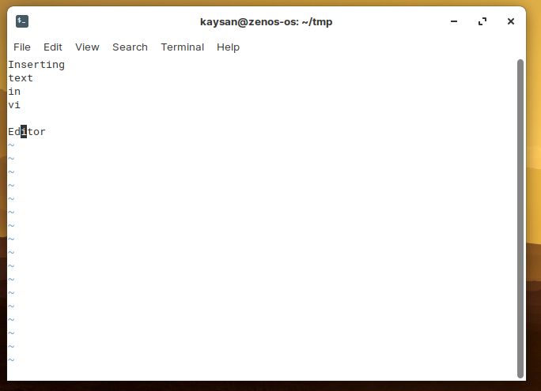

**For more than one occurrence, press ‘n’ to jump to the next occurrence.**

**Navigation:**

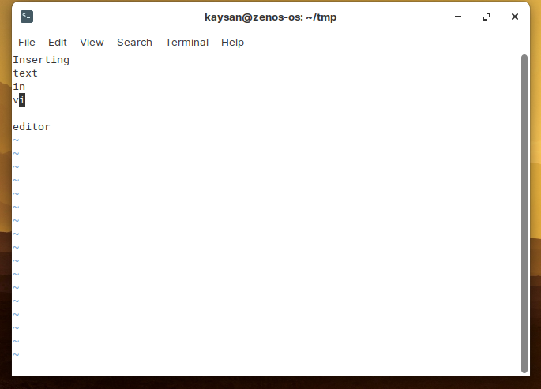

**Press Esc + h to move left in a line,**

**Press Esc + l to move right in a line**

**Press Esc + j to move a line upward,**

**Press Esc + k to move to the next line.**

b) Learn all essential commands like search, search/replace, highlight, show line numbers.

**Search**

**Select the find option and type the keyword you wanted to search for e.g. I search ‘Kaysan’**

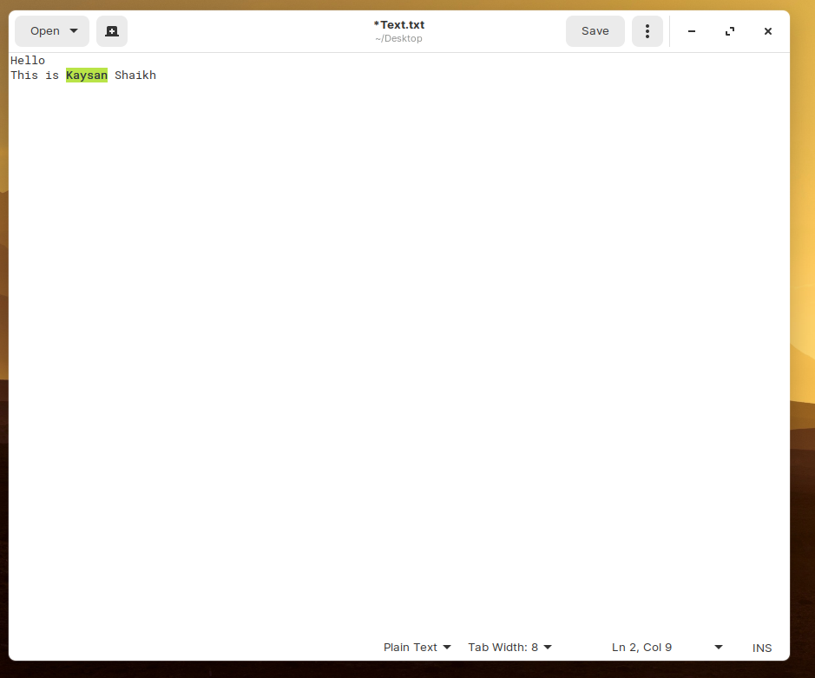

**Search/Replace**

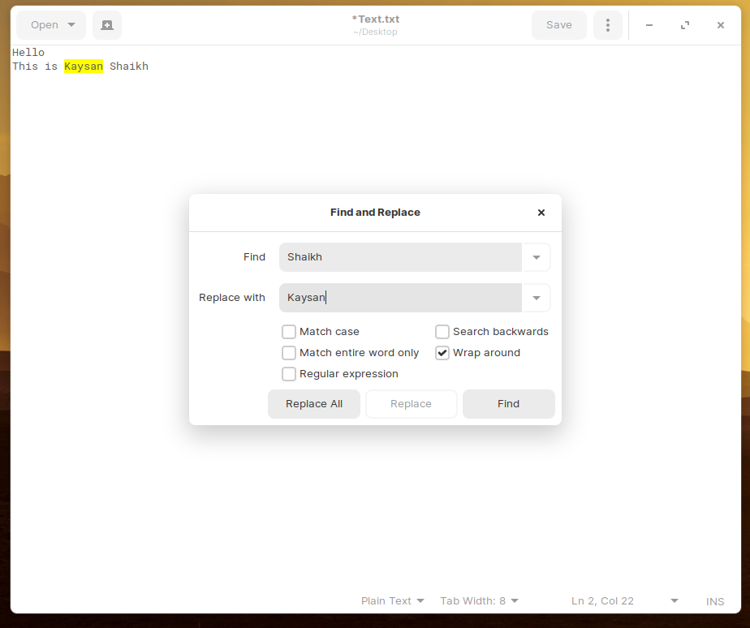

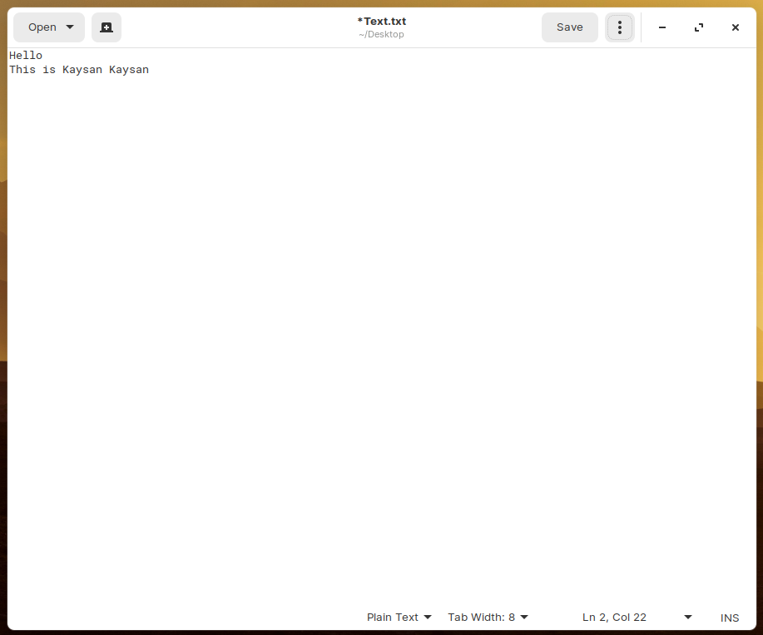

**Highlight**

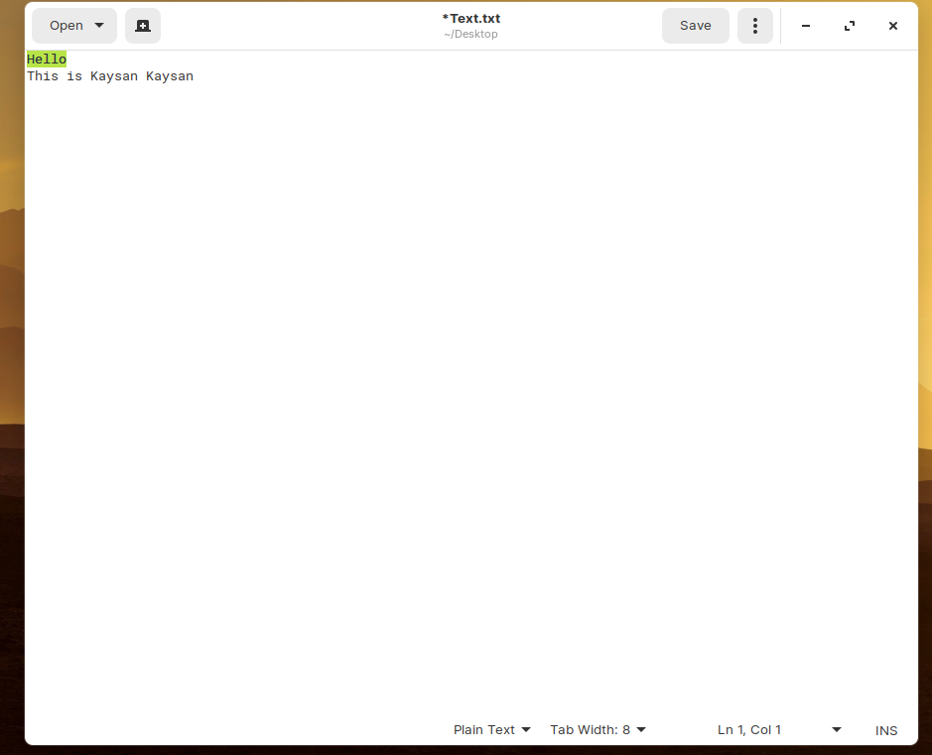

**Show line numbers**

**Go to preference and select display line Numbers**

